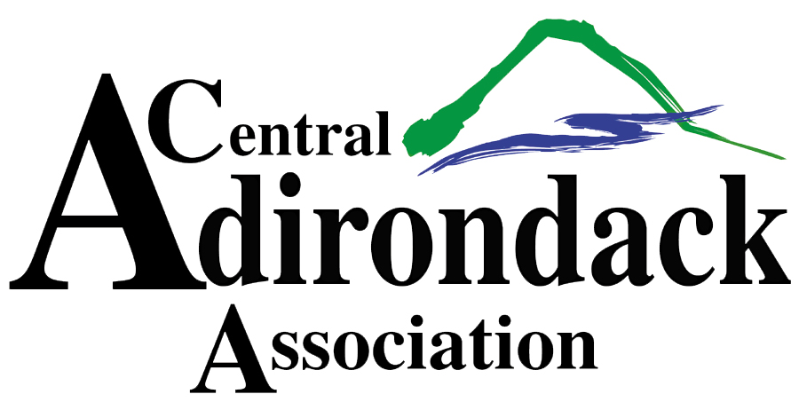
SNODEO VENDOR APPLICATION
DECEMBER 8TH, 9TH & 10TH, 2023
To request booth space, please fill out the form below and return no later than November 15th to the mailing address below. For more info go to SNODEO.COM!
- Booth set up times will be Thursday, 12/7, from 9am-5pm and Friday, 12/8, from 9am-1pm. All vendors must be set up and ready for operation by opening of show.
- Hours of operation; Friday, 12/8, 1-5pm, Saturday, 12/9, 9am-5pm and Sunday, 12/10, 10am-2pm.
- The pavilion will close at approximately 2pm on Sunday. Breakdown will begin at this time. All merchandise must be removed no later than 5pm, 12/10.
- No running machines in the pavilion.
- No set up allowed until booth space paid in full.
- One 8 ft table and 2 chairs per vendor space. Electricity and WIFI available.
- All vendors must provide a certificate of insurance listing the Town of Webb and the Central Adirondack Association additional insured. Please return certificates with application.
- Payments must be received in full prior to November 15th. Make checks payable to the Central Adirondack Association.
- Each vendor is asked to donate a door prize ($25 value) which will be collected and distributed during the event.
- NO REFUNDS. NO RAFFLE TICKETS TO BE SOLD DURING EVENT.
If you have any questions please contact Laurie Barkauskas at laurieb@caany.com or 315-369-6983.
BOOTH SPACE REQUEST FOR SNODEO 2023
BUSINESS NAME;_____________________________________ PHONE:_______________________

ADDRESS:__________________________________________________________________________

CONTACT NAME:___________________________ EMAIL:___________________________________

PRODUCTS SOLD:_____________________________________________________________________

10 X 10 INTERIOR BOOTH SPACE - $250 _______ 10 X 20 INTERIOR BOOTH SPACE - $400 _______
EXTERIOR 10 x 10 SPACE- $150 ________
SIGNATURE:___________________________ DATE:_______________________________

CENTRAL ADIRONDACK ASSOCATION, PO BOX 68, OLD FORGE, NY 13420

